**SQS Quality Assurance:**

**Enhancing the training web application**

Team 6

November 12, 2017

Jake Davis

Dylan Jenkins

Binod Katwal

Manni Mashaee

Customer: SQS

Assignment: Coding

**Implementation**

Source Code

The source code for the project has been hidden from public access. The code is saved in a private repository hosted using Git and one of UK’s various servers. Any access to the code must be given from a current project member.

User’s Manual

The web application has four types of users. An Unregistered User, a User, a Superuser, and Admins. The User’s Manual will cover a typical user interaction.

Once the web application has been set up and the correct database tables created. A user will load up the web application and be presented with a page looking like.

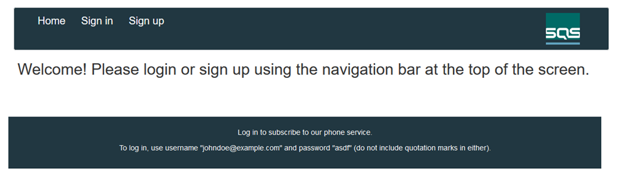

From here a user has two options. To Sign in or Sign up. At this very moment the user is considered an Unregistered User. If the user needs to create/register for an account they may click on Sign up and will be taken to the registration process.

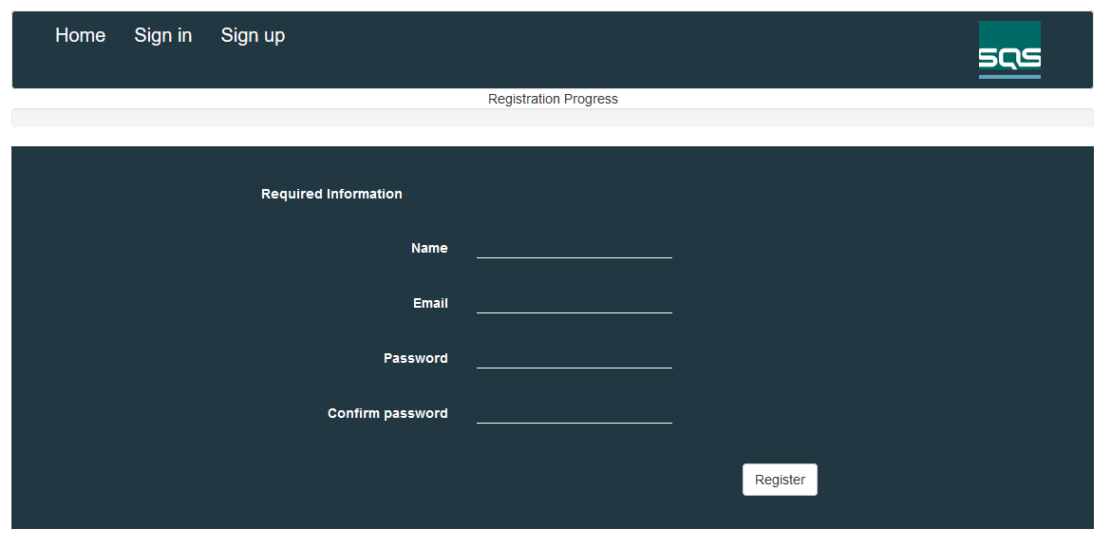

The first page the user is presented with for the registration process is the required information. This information must be filled out in order to create an account. Once this information has been filled out the user will click Register. This will then register the account and verify it not a duplicate.

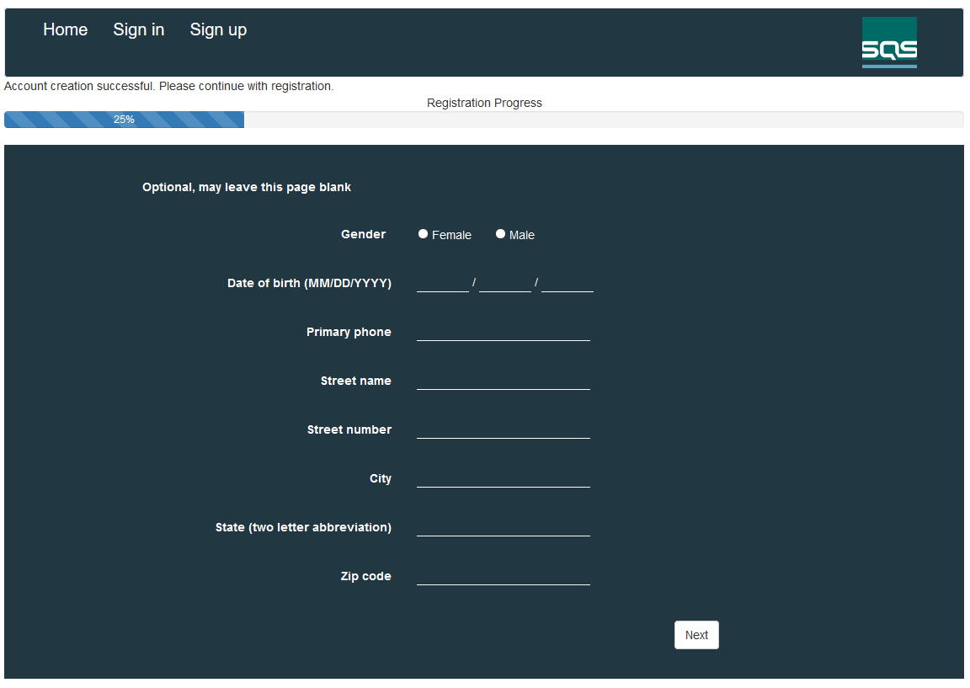

The user will then be brought to the second page in the registration process. This information is entirely optional and may be left blank, if the user wishes to proceed they can simply click Next to proceed to the next page or Sign in to skip the entire registration process. The second page of the registration process is simply an address information page, obtaining basic address information, birthday and gender. When the user clicks Next they will be taken to the third page in the registration process.

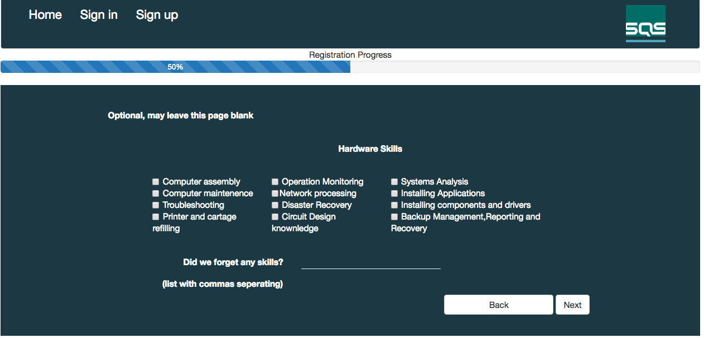  
  
This page is also optional and may be treated the same as the second page. However, the third page is asking for the user's Hardware skills. We have provided check boxes covering the main areas we felt were desirable and left a small textbox at the bottom for the user to add any skills we may have missed. Once again, the user will click Next to proceed to the fourth and final page in the registration process.

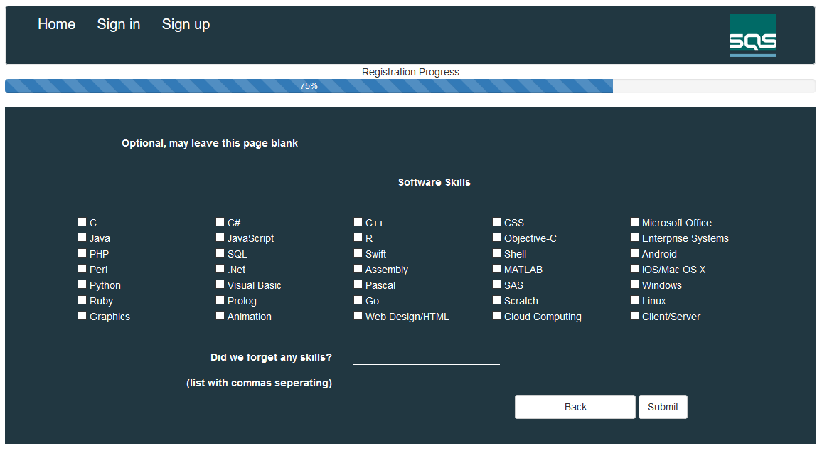

The final page can be treated like the second and third page. The fourth page is asking for the user's Software skills. We have provided check boxes covering the main areas we felt were desirable and left a small textbox at the bottom again for the user to add any skills we may have missed. Finally the user will click Submit to finish the registration process and will be directed back to the home page. Now that the Unregistered User has become a User they may sign in using the credentials entered during registration.

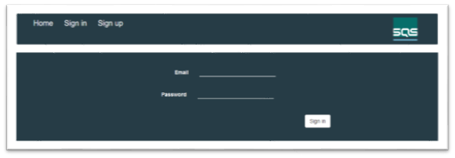

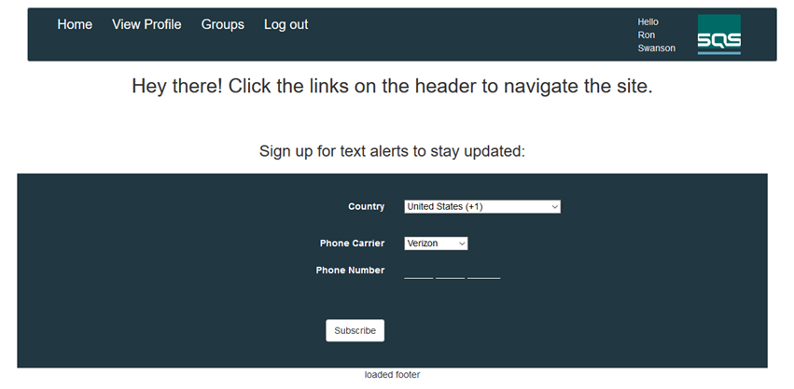

Once the user has signed in they are given a couple more options. They can subscribe to the phone listings placing them in the corresponding database table. From here a User may click to View Profile, simply displaying all the information the user has entered from registration on screen. The other option is to look at Groups, this will direct the user to a page displaying all the users in groups, the groups, and their corresponding leaders in the database on the server. The user may also Log out. Lastly we added an image of the database to give an idea as to what is going on behind the scenes.

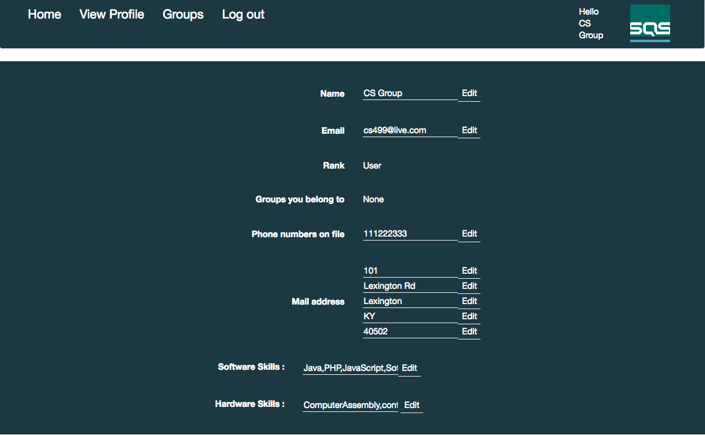

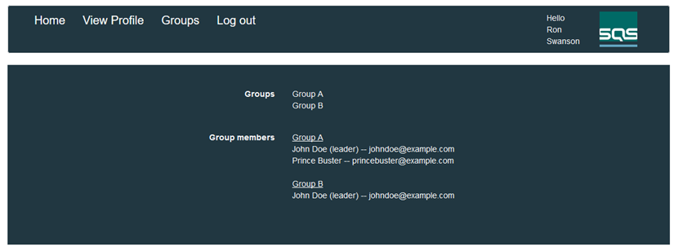

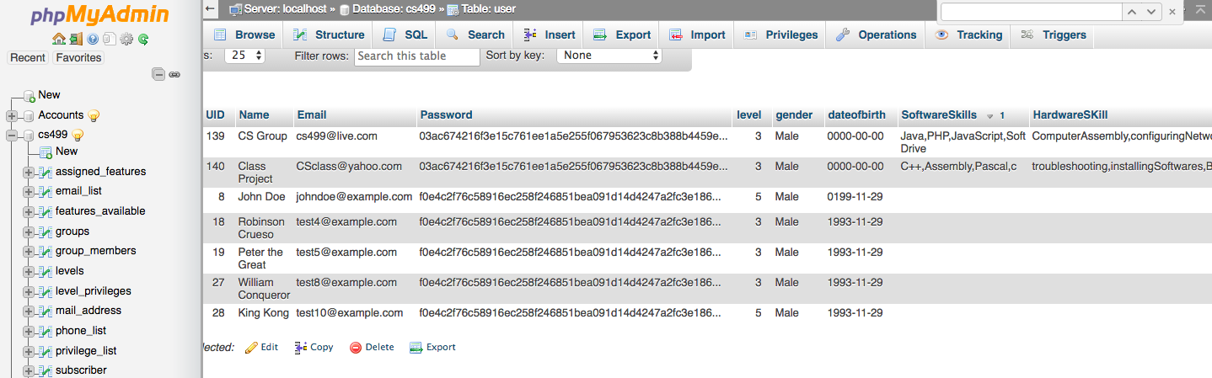

Administrator’s Manual

The Administrator's Manual is really very similar to the User’s. Once the user has logged in, if they are a Superuser or an Admin they will be brought to two different home pages.

Superuser’s Home Page:

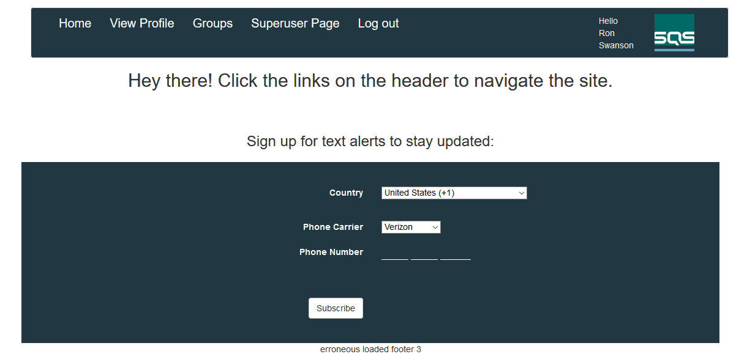

The Superuser's home page looks quite similar to a User’s home page but it has the addition of one option. This is the Superuser Page, from here the Superuser may look at all users registered in the database and has the privilege of being able to add/remove users from groups.

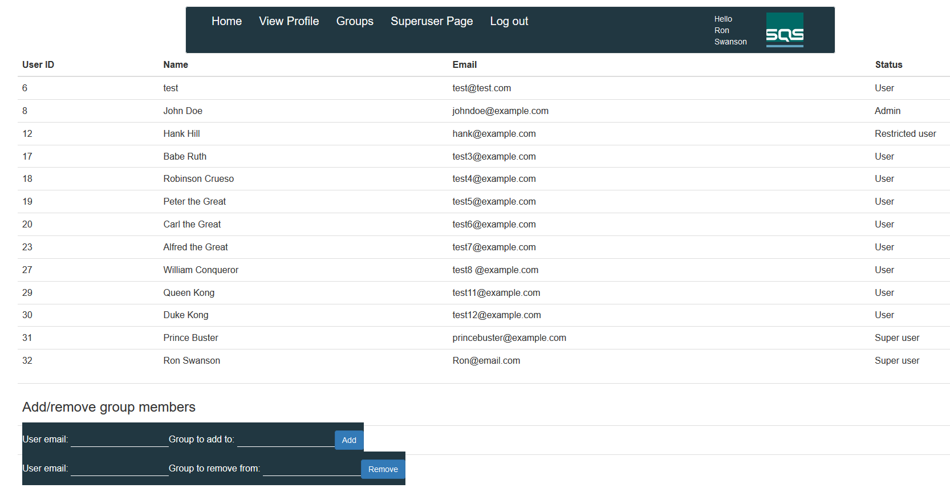

Admin’s Home Page:

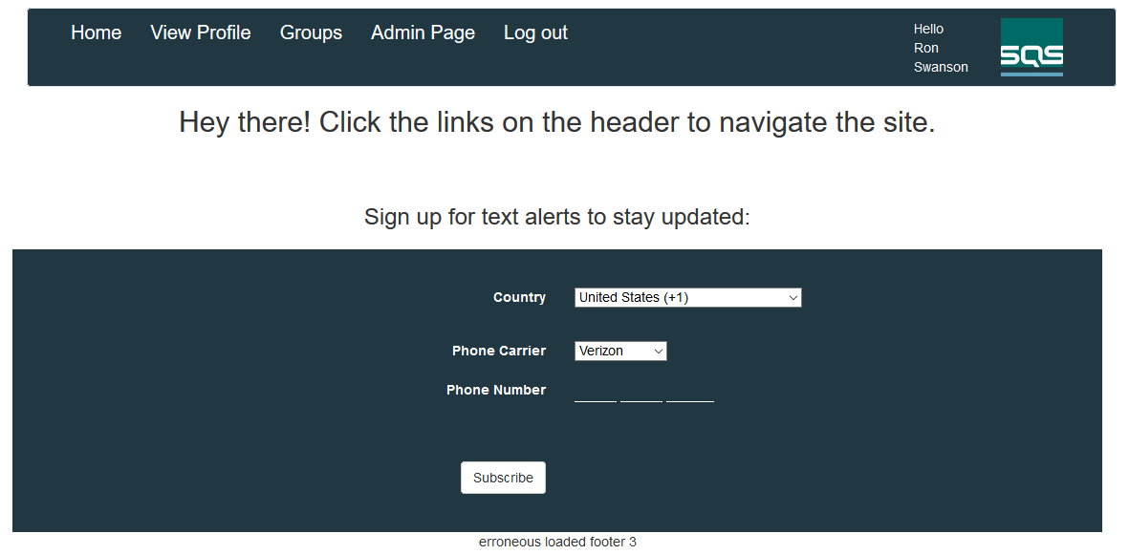

The Admin has one additional option on their home page. This is simply titled Admin Page, below is shown an image of what this page looks like. From there the Admin can look at all users in the database and add/remove users from groups as well as add/remove users as a leader of the group. This is the main difference between the Superuser and the Admin.

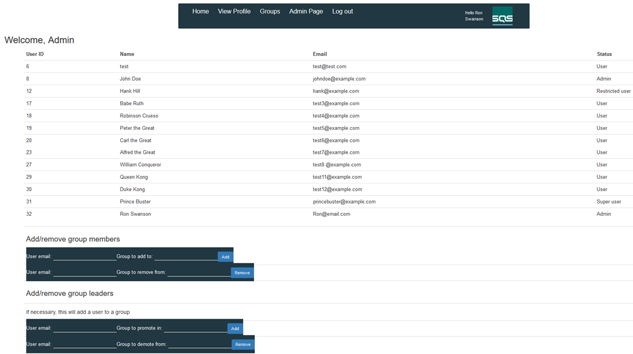

**Testing**

**Test Test Case Success Condition Fail condition Status**

|  |  |  |  |  |
| --- | --- | --- | --- | --- |
| 1 | Valid new user sign up.  *Required information check* | User account created in the database. | User account creation fail and error is displayed. | Pass |
| 1b | Invalid new user sign up.  *Required Information:*  *Passwords don’t match* | User account creation unsuccessful and error is displayed. | User account creation successful. | Pass |
| 1c | Invalid new user sign up.  *Required Information:*  *Email in use* | User account creation unsuccessful and error is displayed. | User account creation successful. | Pass |
| 2 | Valid user sign in. | User login successful.  Redirected to home page. | User login fail. | Pass |
| 2b | Invalid user sign in. | User login unsuccessful.  Error displayed. | User login successful. | Pass |
| 3 | Address information submission | User address information in the database. Visible on user profile. | Information not found in database or on user profile. | Pass |
| 4 | Hardware skills submission | User hardware skills in the database. Visible on user profile. | Skills not found in database or on user profile. | Pass |
| 5 | Software skills submission | User software skills in the database. Visible on user profile. | Skills not found in database or on user profile. | Pass |
| 6 | User update’s hardware skills. | Updated hardware skills in the database and on user profile. | Skills fail to update in the database and/or on user profile. | Pass |
| 6b | User update’s software skills. | Updated software skills in the database and on user profile. | User skills fail to update in the database and/or on user profile. | Pass |
| 7 | Progress bar update. | The progress bar updates according to where the user is in registration process. Forwards or backwards. | Progress bar does not update or does not appear. | Pass |
| 8 | Registration process cookies | User information is retained on the pages during registration process. | User information is not retained. | Pass |

**Metrics**

Product Size

Story Points & Lines of Code

SQS has given us seven features with 29 story points and a total of 12 unit test cases. At about 400 lines of code added to the existing web application. Some lines were altered in order to provide the required features desired and may not have been counted as a new line added.

Complexity

This system does not have inheritance due to the nature of Javascript, html, and php. With no classes or objects there is a lack of an object oriented infrastructure. Coupling between classes is also not applicable since none in our system depend on the other.

Product Effort

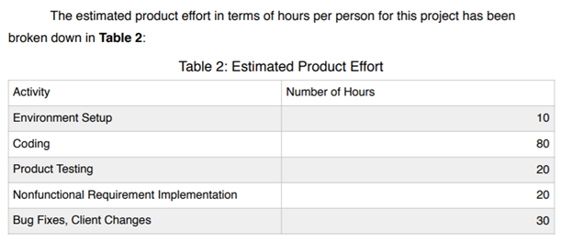

Defects

No defects were found during quality assurance review. Most defects were hammered out during coding phase due to continuous periodic testing.